

**MEHRAN UNIVERSITY OF ENGINEERING AND TECHNOLOGY JAMSHORO**

**Topic: A Quiz Game Show**

DONE BY: **RAFY MUSTAFA**

ROLL NO: **22SW016(SECTION I)**

**DATE: 05-APRIL-2023**

**SOFTWARE ENGINEERING DEPARTMENT (22SW-SECTION #1)**

**A Quiz game show is a type of game that contain MCQS that are designed in such a way that the one who wants to Play the game he/she first have to enter the password that is ‘Rafy’ to enter in the game, if you enter wrong password than the game will not be opened you will be kick off from the game.**

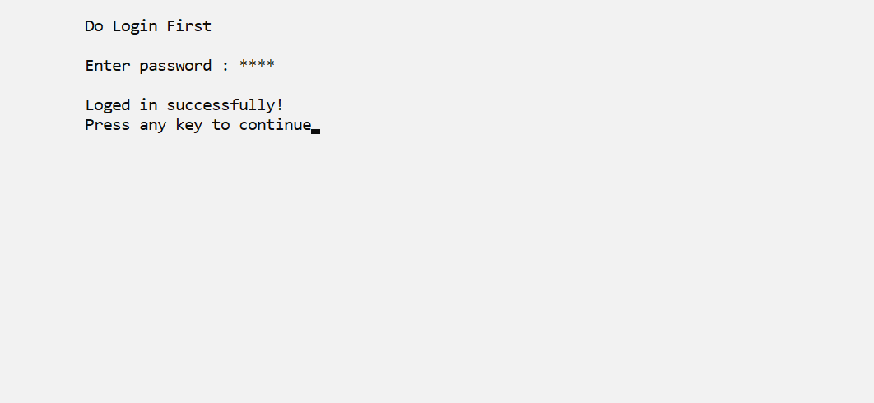

**This game is basically a MCQS test that contain MCQS of Programming Fundamentals, Applied Physics and Functional English. Everyone can give this test if he/she enters the right password to login.**

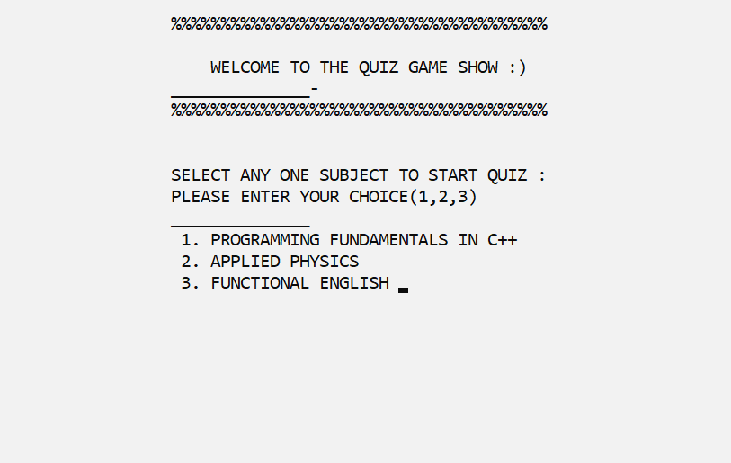

**----------------(*********END*********)--------------**